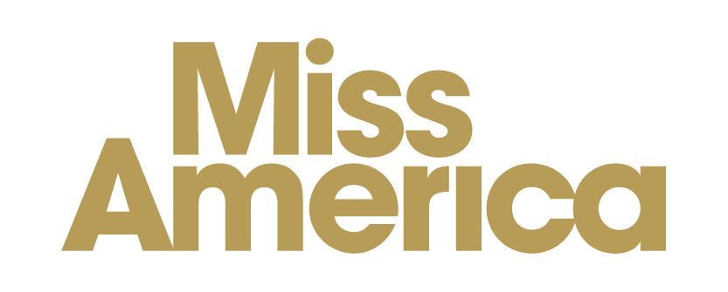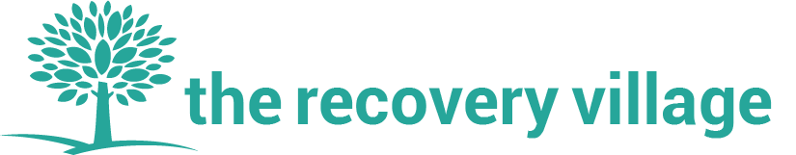
An invitation to mark International Overdose Awareness Day on August 31st, 2020

Dear [Name],

Every August 31st, communities around the world come together to remember those lost to overdose, acknowledge the grief of loved ones left behind, reduce the stigma of drug-related deaths and reduce the impact of overdose.

As we approach the 20th International Overdose Awareness Day this year, the impacts of COVID-19 on health systems and the risks it creates for vulnerable people means this cause has only become more urgent.

As you may be aware, International Overdose Awareness Day activities are held in communities around the world every year.

This year we invite you to join us for [insert details of event].

It would be great if you could encourage people from your organisation to join us at our event this year.

If you can’t make our event this year but would still like to be involved there are plenty of other ways to support International Overdose Awareness Day. We encourage you to:

- Raise awareness through social media using our Twitter handle @OverdoseDay and this year’s hashtags #OverdoseAware and #EndOverdose and #IOAD2020; and
- Spread the word about this year’s campaign through your networks to other organisations and individuals who may be interested in our event.

Best wishes for International Overdose Awareness Day 2020.
Yours sincerely,

[Your Name]
International Overdose Awareness Day is organised by Melbourne-based organisation Penington Institute (www.penington.org.au) - email: info@overdoseday.com.au

