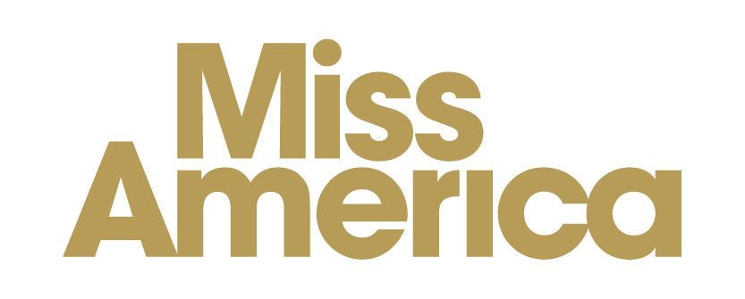

WHEREAS, the [NAME OF MUNICIPALITY] does affirm and acknowledge the harm and hardship caused by drug overdose; and

WHEREAS, we recognize the purpose of International Overdose Awareness Day as remembering loved ones lost to overdose and ending the stigma of drug-related deaths; and

WHEREAS, we resolve to play our part in reducing the toll of overdose in our community, which claimed the lives of more than [NUMBER OF OVERDOSE DEATHS IN STATE/COUNTY] [NAME OF STATE] residents in 2018 together with countless more affected forever; and

WHEREAS, we affirm that the people affected by overdose are our sons and daughters, our mothers and fathers, our brothers and sisters, and deserving of our love, compassion and support;

THEREFORE, I, [NAME OF MAYOR], Mayor, do hereby proclaim August 31st, 2020 as Overdose Awareness Day in [NAME OF MUNICIPALITY].

Source for 2018 overdose deaths by state: https://www.cdc.gov/drugoverdose/data/statedeaths/drug-overdose-death-2018.html

